**Style Guidelines for Final Year Project ReportsReview Hub**

**Final Year Project**

**Session 2013-2017**

A 4th Year Student

A project submitted in partial fulfilment of the

COMSATS-Lancaster Dual Degree

of

BSc. (Hons.)BS in Computer Science / Software Engineering (CIIT)

BS in Computing / Software Engineering (LU)

**C:\Documents and Settings\drzhabib\Desktop\lancaster-university-logo.png**

Department of Computer Science

COMSATS Institute of Information Technology, Lahore

16 May 2017

**Project Detail**

|  |  |  |  |  |  |
| --- | --- | --- | --- | --- | --- |
| Type (Nature of project) | | [ ] **D**evelopment [ ] **R**esearch [ ] **R**&**D** | | | |
| Area of specialization | |  | | | |
| **Project Group Members** | | | | | |
| Sr.# | Reg. # | | Student Name | Email ID | *Signature |
| (i) | DDP-FA13-BCS-149 | | Talal Mirza |  |  |
| (ii) | DDP-FA13-BCS-053 | | Humza Waseem Bhatti |  |  |
| (iii) | DDP-FA13-BCS-017 | | Ali Haider Babar |  |  |

*The candidates confirm that the work submitted is their own and appropriate credit has been given where reference has been made to work of others

**Plagiarism Free Certificate**

This is to certify that, I am ________________________ S/D/o _______________________, group leader of FYP under registration no CIIT/_________________/LHR at Computer Science Department, COMSATS Institute of Information Technology, Lahore. I declare that my FYP proposal is checked by my supervisor and the similarity index is ________% that is less than 20%, an acceptable limit by HEC. Report is attached herewith as Appendix A.

Date: ____________ Name of Group Leader: ________________________ Signature: _____________

Name of Supervisor: _____________________ Co-Supervisor (if any):____________________

Designation: _____________________ Designation: _____________________

Signature: _____________________ Signature: _____________________

HoD: _____________________

Signature: _____________________

**Abstract**

Web technologies is of the great importance to develop dynamic and interactive web based applications.The aims of this project is to build an online web based review site. Which will provide the professional reviews of products according to Pakistani market. Reviews serve as luxury to people which eradicate the risk while buying the product with knowledge about it or by knowing the performance as well. As a lot of online review content is available but the main focus of this project is Pakistani market. No prominent or solidary platform is in place to tackle and respond according to the local trends and psyche of customers. Where this web application will reflect according to the trend among major in-demand categories, which includes mobile phones, movies, food, technology gadgets and devices. In which reviews will be posted by hired food critics, film critics and technology enthusiasts. All these hired proficient will have their own ranks ranked according to quality of their reviews.

**Acknowledgement**

First of all we would like to thank to Allah Almighty, Who helped us to the powerful achievement of the final year project. Without His help we were not able to finish our FYP-1 report. A special thanks to our final year project Supervisor, Mr. Adnan Ashraf, whose help, stimulating suggestions and encouragement, helped me to coordinate my project. I would also like to acknowledge appreciation of our Co-Supervisor Mr. Mohsin Mehdi, a humble and friendly person who has always been there for us to encourage, motivate and show us the way to tackle every problem with zeal. A great appreciation for the staff of our Computer Science department, who gave the permission to use computer labs for our research and development for our projects, and also assist us to complete the development and documentation rigs.

*“When you invite people to share in your miracle, you create future allies during rough weather.”*

*― Shannon L. Alder*

**Table of Contents**

Chapter 1. Introduction 8

1.1 Introduction 8

1.2 Literature Review 8

1.3 Goals and Objectives 9

1.4 Assumption and Constraints 9

1.4.1 General Constraints 10

1.4.2 General Assumptions 10

1.5 Project Scope 10

Chapter 2. Requirement Analysis 10

2.1 Existing System Study 10

2.2 Stakeholders List 12

*2.3* Requirements elicitation 12

2.3.1 Business Requirement 12

2.3.2 Functional Requirements 13

2.3.3 Non-Functional Requirements 15

2.4 Use Case Design 18

2.5 Use case descriptions 20

2.5.1 Registration 20

2.5.2 Login 21

2.5.3 Manage Profile 22

2.5.4 View Review 24

2.5.5 Search 25

2.5.6 Interact with Review 26

2.5.7 Manage Followers 27

2.5.8 Post Review 28

2.5.9 Logout 29

2.6 Software development life cycle model 30

2.6.1 Justification 30

Chapter 3. System Design 31

3.1 Architecture Diagram 31

3.2 Work Breakdown Structure (WBS) 32

3.3 Activity diagram 33

3.3.1 User Sign In + Sign Up 33

3.3.2 Newsfeed 34

3.3.3 Create Review 35

3.3.4 CMS Login 36

*3.4* Database Design 37

3.5 Gantt chart 38

Chapter 4. Risk Analysis 39

4.1 Risks 39

4.2 RMMM (Risk Mitigation, Monitoring, and Management) 40

*Chapter 5.* Conclusion 42

5.1 Project Summary 42

5.2 Future Work 42

Chapter 6. References 43

Table of Figure

Figure 1 ReviewHub Usecase 1 19

Figure 2 ReviewHub Usecase Cont. 20

Figure 3 ReviewHub Architecture Diagram 31

Figure 4 ReviewHub WBS 32

Figure 5 Signin/Signup Activity 33

Figure 6 Newsfeed Activity 34

Figure 7 Create Review Activity 35

Figure 8 CMS Login Activity 36

Figure 9 ReviewHub Database 37

Figure 10 Gantt Chart (ReviewHub) 38

# Introduction

## Introduction

The web application will serve as lively place to help and become a trusted consultee for people to find the right product for them. The help and trust comes from the comfort of being aware of product and getting the satisfaction after buying it. The reviews help a lot as they may be given by different people who have already experienced or used a product in different scenarios or conditions that might match the potential buyer and serve as how well the product might suit him.

The functionality of the web application has two side of flow, one worked by the reviewers (administrators) and the second by the end-user availing the service.

The application works I a way that each category will have one administrator. Each will select and have his own team of reviewers under his category. These reviewers will post reviews about products. Each reviews can have his unique bio telling his style of reviews and expertise.

User will sign up to have his own feed page. User can visit category page or follow specific reviewers to make their posted reviews appear on feed page. Users can comment and give ‘thumbs up/down’ sort of rating to contenders to increase their rank. Users can send a request for a particular review or suggestion to a specific reviewer or category in general. The reviewers rank will be evaluated by user feedback and based on administrators given badges.

There will be a mechanism to check if the reviewers are posting plagiarized reviews or fake/wrongly reviews. The very basic check is steam-like method, if a review gets too many thumbs down it will be flagged as suspicious. Other methods include repetition of review wording and Turnitin like system of cross checking it off internet if already available.

Recognized stakeholders in this application and service’s zone are users/potential product buyers, vendors, product companies, sellers, restaurants, cinemas and reviewers.

## Literature Review

The following contains the study of existing literature related to the product

Review sites have grown on people with the passage of time and more e-methods introduced to carry out activities. People buy products online without ever experiencing them physically or visit places with the hope of knowing something beforehand but not visiting it physically. People hope to get opinions of others. In such cases reading an online review of the thing is becoming pretty main stream. But these review are heavily affected by the way people think as mentioned in (1) .

In this paper main observation is how the people thinking effect information gathering process. With the time people have more rich-opinions resources such as different review site and blogs, people engaged more towards these technologies to get authentic information. Now due to sudden change in technology and more information availability new systems are designed such that they set the opinion of consumer as first priority as it becomes the important part now.

The world of reviews not only effect itself but also has a wide range effect on the workings of shopping site. It is observed that the review given on shopping sites varies in different ways. They categorize the evaluation of these reviews in three biases which are based on set of specifications which are defined first. It shows a classification based technique to detect the low quality reviews. The results shows that the methods used are efficiently filtering low-Quality reviews.

“Consumer Awareness and Use of Product Review Websites (2013) (2)” reports on a study for assessment of consumer awareness, and use, of product review websites. Particularly e-opinion leadership, customer’s less influence towards information and gender based awareness for the usage of these review websites. This was done with the help of a bunch of participants from different demographics on awareness of review sites, extent usage of review sites and difference of usage on the basis of individuals as well.

## Goals and Objectives

This section contains the define goals and determined objectives of the project.

The web application will serve as lively place to help and become a trusted consultee for people to find the right product for them. The help and trust comes from the comfort of being aware of product and getting the satisfaction after buying it. The reviews help a lot as they may be given by different people who have already experienced or used a product in different scenarios or conditions that might match the potential buyer and serve as how well the product might suit him.

The functionality of the web application has two side of flow, one worked by the reviewers (administrators) and the second by the end-user availing the service.

The application works I a way that each category will have one administrator. Each will select and have his own team of reviewers under his category. These reviewers will post reviews about products. Each reviews can have his unique bio telling his style of reviews and expertise.

User will sign up to have his own feed page. User can visit category page or follow specific reviewers to make their posted reviews appear on feed page. Users can comment and give ‘thumbs up/down’ sort of rating to contenders to increase their rank. Users can send a request for a particular review or suggestion to a specific reviewer or category in general. The reviewers rank will be evaluated by user feedback and based on administrators given badges.

There will be a mechanism to check if the reviewers are posting plagiarized reviews or fake/wrongly reviews. The very basic check is steam-like method, if a review gets too many thumbs down it will be flagged as suspicious. Other methods include repetition of review wording and Turnitin like system of cross checking it off internet if already available.

Recognized stakeholders in this application and service’s zone are users/potential product buyers, vendors, product companies, sellers, restaurants, cinemas and reviewers.

## Assumption and Constraints

This section holds list of generic assumption related to the website and constraints within which it would work

### General Constraints

* The Interface will be in English only.
* The system is working for single server.
* The user have to give & take feedback about the products and services.
* The visitor can only visit website with limited access.
* Only registered reviewers can interact with reviews with full user level access.
* The computer must be connected to internet

### General Assumptions

* User must have a basic computer knowledge.
* User must have a basic knowledge of English.
* The system must be able to respond to database software within reasonable time.

## Project Scope

In this section the scope of the project will be discussed.

* This project will develop and deliver a new website.
* The main scope with respect to end-users of this project is Pakistani market and to facilitate people of all classes and mindset. Platform scope is web with future work in smart phone field with requirement’s to increase according to platform.

# Requirement Analysis

This section contains analysis of the needs and conditions to meet project completion

## Existing System Study

This section holds the information of the preexisting websites in the market with comparable service being provided to his project

The systems which are related to this project are following:

* Eatoye/Foodpanda

These sites have similar work functionalities for review but with their main aim as online-food-ordering the reviews aren’t flexible. The reviews found on these site are only restaurant based and about the experiences rather than directed on food and dishes.

* IMDB

One of the largest database for movies to this point and holding numerous reviews and ranking them accordingly as successful but yet again not meeting the objective of this service of suggesting according to the market and culture of Pakistan.

* GSM Arena

The site contains mass scaled data related to mobile phones but all of these phone models are international. The reviews on this site miss two points, one that these are international phone models and local models have different specs therefore leading to wrong suggestion to users. Secondly abundance of reviews on these sites are given on phones popular and in demand internationally whereas the local Pakistani market customers have their own preferences of specs and difference in buying power of markets.

## Stakeholders List

The section lists out the present stakeholders of the project

|  |  |  |
| --- | --- | --- |
| Name | Roles | Responsibilities |
| Mr. Adnan Ashraf | Project Supervisor | Monitor and Supervise Project |
| Mr. Mohsin Mehdi | Co-Supervisor | Monitor, Supervise, help in resources |
| Talal Mirza | Group Leader, Programmer, Documentation | Backend programming, Front end Design, Documentation |
| Humza Waseem | Programmer, Documentation | Backend programming, Front end Design, Documentation |
| Ali Haider Babar | Programmer, Documentation | Backend programming, Front end Design, Documentation |
| User | Reviewers, visitors, food authorities, cinemas (movie related people), technology companies etc. | Visit website, help in data crawling, and help in to identify flaws, tell how to make better, use reviews to get user feedback for their product. |

## Requirements elicitation

In the following section requirement gathering will be discussed.

### Business Requirement

The following are the details of business solution for the project

A web application that will provide the professional reviews of products according to Pakistani market. Reviews serve as luxury to people by not risking to buy product with no knowledge about it or known performance. With this luxury available online on a lot platforms, a need was unfulfilled regarding local Pakistani market. Where this web application will reflect according to the trend among major in-demand categories.

### Functional Requirements

This section defines the functionalities and components of the website by addressing different pages.

#### Splash Page

* System will open “Get Register” or “Login Popup”. System will ask for email address and if email is registered it will take to login popup else to get registered popup.
* System will show “search “option on splash page to search in whole system.
* System will show trending reviews on splash page.
* System will show category badges and contain link to redirect to further categories.
* System will have a link to application to “Apply as reviewer”.
* System will allow guest to view splash page.

#### Register Popup

* System will allow visitor to get registered.
* System will ask user visitor to provide information to get registered i.e. username, password and date of birth.
* System will register the visitor after getting visitor`s information. Now visitor is user who can later on edit his/her profile
* System will allow to register any visitor free of cost.

#### Login Popup

* System will allow user to login
* System will verify that user`s entering username and password is correct.
* System will allow user to visit his/her personal page if user`s username and password is correct.
* System will allow user to reset his password by entering his/her email address.
* System will allow user to logout.

#### Profile Page

* System will allow user to upload profile picture.
* System will allow user to fill in his/her personal information i.e. first name, last name, CNIC, Religion, about etc.

#### Search

* The user can search the whole system.
* System will allow to both registered and unregistered users to access to this service.

#### Home page

* System will have search bar at top to search whole system.
* System will have the username displayed at the top right corner as hyperlink to profile.
* Accessibility icon will be at top right corner to access accessibility option such as settings, saved reviews, logout etc.
* Home page will have three tabs i.e. Live feed, subscribe, categories.
* Live feed will display the latest/live reviews posted by reviewers. This tab will be available to registered user as well as guest user.
* Subscribe tab will show the reviews posted by reviewers you have followed. (Only for Registered)
* Categories tab will display the different badges which will link to expanded menu for each category. (Available to both registered and guest user).

#### Administrator/Reviewers Module

* System will allow the administrator to manage the web application.
* System will allow administrator to manage reviewers and user.
* System will provide the editor to reviewers to write and manage reviews.
* System will allow reviewers to manage their profile.
* System will show the statistics reports to administrator as well as reviewer.

#### User Module

* System will user to register as a member.
* System will allow user to login.
* System will allow user to manage his/her profile.
* System will allow user to interact with the reviewers.
* System will allow the user to follow/subscribe reviewers.
* System will allow user to post reviews.
* System will allow user to rate/like reviews.
* System will allow user to manage his/her timeline.

#### Review Detection Module

* System will detect review duplication.
* System will be equipped with review spamming filter.
* System will check for biased reviews.
* System will detect fake account reviews.
* System will be equipped with review plagiarism detection method.

### Non-Functional Requirements

*This section defines the behavior of the website and its constraints.*

#### Maintainability

* In case of a failure, a re-initialization of the application will be done.
* Also the page design is being done with modularity in mind so that maintainability can be done efficiently.
* So when website will be updated with time then it will still be maintained.

#### Reliability

* The system provides storage of all databases on redundant computers.
* The reliability of the overall application depends on the reliability of the separate components.
* The main pillar of reliability of the application is the backup of the database.
* It is continuously maintained and updated to reflect the most recent changes.

#### Securities

* The application must automatically log out all customers after a period of inactivity.
* The application should not leave any cookies on the customer’s computer containing the user’s password.
* The application back-end servers shall only be accessible to authenticated administrators.
* Sensitive data will be encrypted before being sent over insecure connections like the internet.

#### Availability

* The website should be available at all times.
* The user can access it using a web browser anytime, only restricted by the down time of the server on which the system runs.
* In case of a hardware failure or database corruption, a replacement page will be shown.
* Also in case of a hardware failure or database corruption, backups of the database should be retrieved from the server and saved by the administrator.
* Then the service will be restarted. It means 24 X 7 availability.

#### Portability

* The end-user part is fully portable.
* Any platform using any web browser should be able to use the features of the system.
* It will include any hardware platform that is available or will be available in the future.
* The website will run on mobiles, laptops and other similar platforms.

#### User Friendly

* The website should provide best possible view to the customers and viewers.
* They will be able to find the desired things easily.
* It will give the user many advantages like time saving and easy searching.

#### Performance

* The website will provide quick response in light traffic.
* Its performance will not be affected even by heavy traffic of users and will provide normal response time also in heavy traffic.
* The site will save cookies of same user so that when he try to access the same thing again so it could be accessed much faster.

#### Capacity

* The website will have capacity to entertain many users at same time.
* Different users can do desired activities and it won’t affect the performance.
* Even when content on website will be increased, it will also not affect the speed of the site.
* Otherwise visitors won’t hang around on a slow website.

#### Usability

* This feature will give ease of use to the customer.
* All things will be assembled in pattern.
* So that user could easily access the functionality he wants the application to perform.
* There won’t be complex menus on the site to confuse the user.

#### Recovery

* The feature will allow the site to recover from some serious issue.
* For this backup will be saved so that they could be used to get site back to fully functional form.
* This feature will also help to recover lost data.
* So this feature is really important to avoid any issue and recover the data again.

## Use Case Design

This section contains use case diagrams user's interaction with the system along with actors of the website.

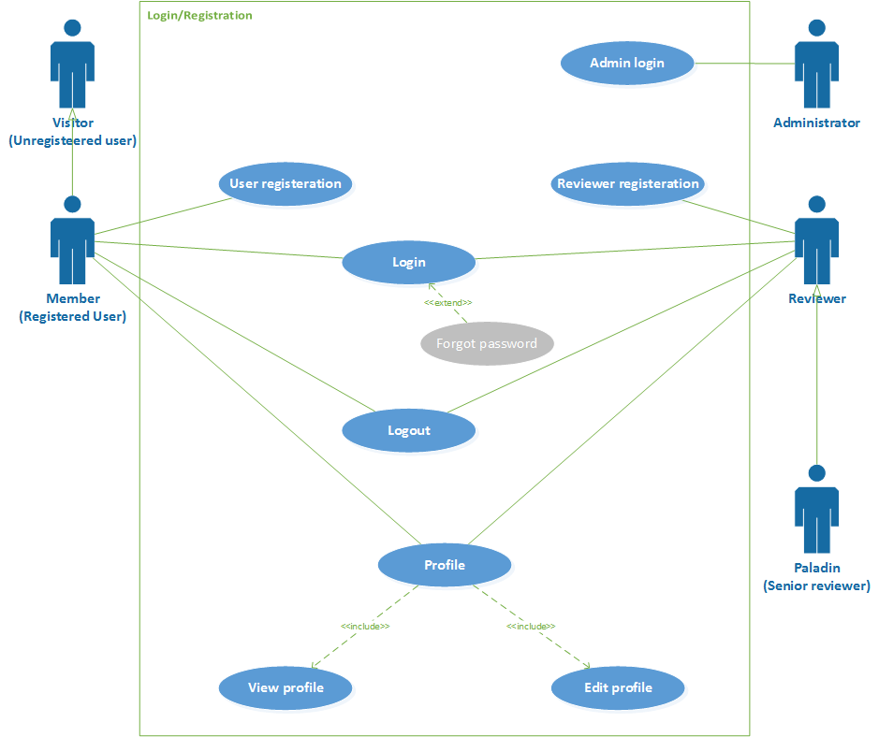

Figure 1 ReviewHub Usecase 1

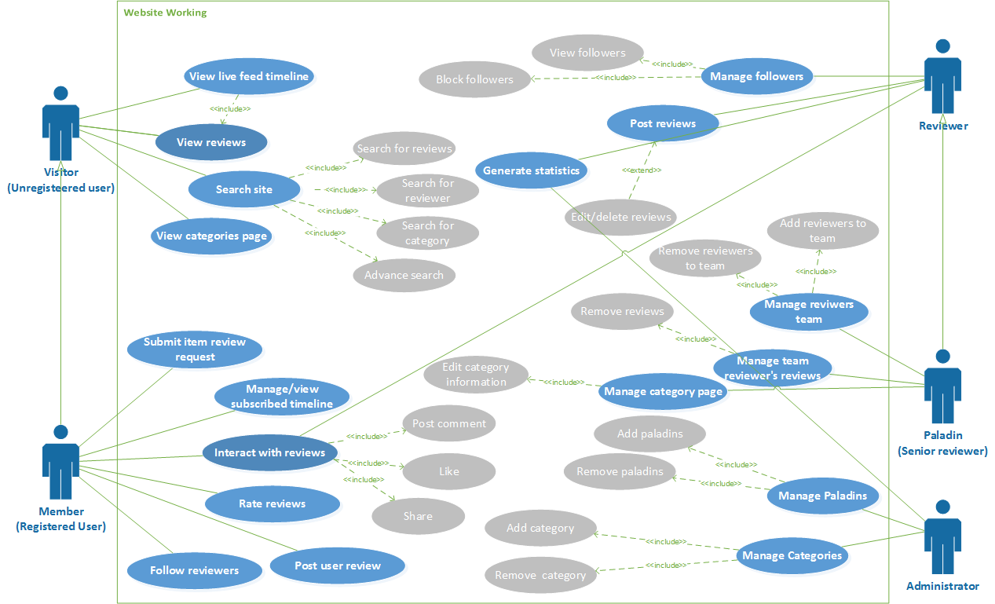

Figure 2 ReviewHub Usecase Cont.

## Use case descriptions

Below are the detailed working of primary and complex use cases*.*

### Registration

|  |  |  |  |
| --- | --- | --- | --- |
| **Use case ID: 001 Use case Name: Registration** | | | |
| **Priority high** | | | |
| **Actors:** Member, Reviewer | | | |
| **Use Case Summary** | Registration allows the Members and Reviewer to register to the website. | | |
| **Pre-condition:** | They have valid email ids or social media account | | |
| **Normal Course of Events** | | | **Alternate Path** |
| 1. The Use case starts when the Member/Reviewer comes to the website. | | |  |
| 1. The Member/Reviewer will select Register link to register. | | |  |
| 1. A form will open where the user will enter a unique username and proceed by clicking next | | | 3(a) A person can do registration by selecting Facebook or Gmail account instead |
| 1. A form will be opened to enter basic information such as password, email and date of birth | | |  |
| 1. On pressing Submit button, email will be sent for verification | | |  |
| 1. The user will click the verification link from mail | | |  |
| 1. If the verification link is working and not expired, user is redirected to website and is successfully registered | | | 7(a) If verification link is expired or broken, the link will be regenerated and resent to the user email |
|  | | |  |
| **Post Conditions** | | | |
| The Member/Reviewer will successfully be registered to website. | | | |
| **Use Case Cross References** | | | |
| **Includes** | | None | |
| **Extends** | | None | |
| **Exceptions** | | | |
| **2a.** If the Member/Reviewer is not verified he/she will not be registered. | | | |

### Login

|  |  |  |  |
| --- | --- | --- | --- |
| **Use case ID: 002 Use case Name: Login** | | | |
| **Priority high** | | | |
| **Actors:** Admin, Member, Reviewer | | | |
| **Use Case Summary** | Login allows the Admin, Member and Reviewer to Login to their account on the website. | | |
| **Pre-condition:** | They are already registered to the website. | | |
| **Normal Course of Events** | | | **Alternate Path** |
| 1. The use case starts when the user opens the website. | | |  |
| 1. The user will click the login link | | |  |
| 1. In the form opened, the user will provide the username or email and password to his account | | |  |
| 1. On pressing login button the user will be logged in to the website. | | | 4(a) if the details are incorrect, the user will fail to login and will be asked to re-enter correct details |
|  | | |  |
| **Post Conditions** | | | |
| The Admin/Reviewer/Member will successfully be logged in to website. | | | |
| **Use Case Cross References** | | | |
| **Includes** | | None | |
| **Extends** | | Forgot password | |
| **Exceptions** | | | |
| **2a.** If the user is not registered he will not be logged in | | | |

### Manage Profile

|  |  |  |  |
| --- | --- | --- | --- |
| **Use case ID: 003 Use case Name: Manage Profile** | | | |
| **Priority medium** | | | |
| **Actors:** Reviewer, Member | | | |
| **Use Case Summary** | Manage profile allows the Reviewer and Member to view, add and update their profile information. | | |
| **Pre-condition:** | They must have an account and logged in. | | |
| **Normal Course of Events** | | | **Alternate Path** |
| 1. The use case starts when the user opens the website. | | |  |
| 1. The reviewer and member will click on profile button | | |  |
| 1. A person can view profile with details such as name, profile picture, about information, follows, follower(in case of reviewers), review posts etc. | | |  |
| 1. The user will be able to update all above information by clicking ‘edit profile’ button | | |  |
| 1. On pressing save button user will see the message "Profile successfully updated". | | | 5(a) Putting erroneous information will result in not updating any field in the prolife and a message will be displayed “Profile not updated” |
|  | | |  |
| **Post Conditions** | | | |
| The Reviewer/Member will successfully view/updated profile | | | |
| **Use Case Cross References** | | | |
| **Includes** | | View profile, edit profile | |
| **Extends** | | None | |
| **Exceptions** | | | |
|  | | | |

### View Review

|  |  |  |  |
| --- | --- | --- | --- |
| **Use case ID: 004 Use case Name: View Review** | | | |
| **Priority high** | | | |
| **Actors:** Member, Visitor | | | |
| **Use Case Summary** | View review allows the Member/Visitor to view the detail review post on the website. | | |
| **Pre-condition:** | User is logged in to the website. | | |
| **Normal Course of Events** | | | **Alternate Path** |
| 1. The use case starts with user visiting the website | | |  |
| 1. The user is either viewing the timeline or searches for a review | | |  |
| 1. The user will then click review to open detailed review | | |  |
|  | | |  |
| **Post Conditions** | | | |
| The Visitor/Member will successfully be shown with the detailed review post | | | |
| **Use Case Cross References** | | | |
| **Includes** | | None | |
| **Extends** | | None | |
| **Exceptions** | | | |
|  | | | |

### Search

|  |  |  |  |
| --- | --- | --- | --- |
| **Use case ID: 005 Use case Name: Search** | | | |
| **Priority medium** | | | |
| **Actors:** Visitor, Member | | | |
| **Use Case Summary** | Search for review, reviewer or category on website. | | |
| **Pre-condition:** | User should be on website | | |
| **Normal Course of Events** | | | **Alternate Path** |
| 1. The use case starts when the user is on home page | | |  |
| 1. The user will type a specific keyword or line and search | | | 2(a )The user can click advance search and apply filters to generate specific results |
| 1. Results will be displayed from reviews, reviewers or category | | |  |
|  | | |  |
| **Post Conditions** | | | |
| The user will successfully use search feature to generate list of search result. | | | |
| **Use Case Cross References** | | | |
| **Includes** | | Search for reviews, search for reviewer, search for category, advance search | |
| **Extends** | | None | |
| **Exceptions** | | | |
|  | | | |

### Interact with Review

|  |  |  |  |
| --- | --- | --- | --- |
| **Use case ID: 006 Use case Name: Interact with review** | | | |
| **Priority high** | | | |
| **Actors:**  Member, Reviewer, Paladin | | | |
| **Use Case Summary** | The user can interact with the reviews posted by comment like and share | | |
| **Pre-condition:** | The user must be logged in | | |
| **Normal Course of Events** | | | **Alternate Path** |
| 1. The use case starts when the user opens the detailed review | | |  |
| 1. The user can then either comment below the review or like or share the review | | |  |
|  | | |  |
| **Post Conditions** | | | |
| The user will successfully do either of the activities | | | |
| **Use Case Cross References** | | | |
| **Includes** | | Like, post comment, share | |
| **Extends** | | None | |
| **Exceptions** | |  | |

### Manage Followers

|  |  |  |  |
| --- | --- | --- | --- |
| **Use case ID: 007 Use case Name: Manage followers** | | | |
| **Priority medium** | | | |
| **Actors:**  Reviewer, Paladin | | | |
| **Use Case Summary** | The reviewer/paladin will manage the followers | | |
| **Pre-condition:** | The reviewer/paladin should be logged in | | |
| **Normal Course of Events** | | | **Alternate Path** |
| 1. The use case starts with user being on profile page | | |  |
| 1. The user clicks on followers list | | |  |
| 1. The user can see all the members on the website who are following him/her | | | 3(a) The user can also select a specific member of the site and block him/her |
|  | | |  |
| **Post Conditions** | | | |
| The list of followers will be populated and/or a specific member will be blocked | | | |
| **Use Case Cross References** | | | |
| **Includes** | | View followers, Block followers | |
| **Extends** | | None | |
| **Exceptions** | | None | |

### Post Review

|  |  |  |  |
| --- | --- | --- | --- |
| **Use case ID: 008 Use case Name: Post review** | | | |
| **Priority high** | | | |
| **Actors:**  Reviewer, Paladin | | | |
| **Use Case Summary** | Reviewer/Paladin will post a review on the site | | |
| **Pre-condition:** | Reviewer/Paladin is logged in | | |
| **Normal Course of Events** | | | **Alternate Path** |
| 1. The use case starts when user clicks the new review button | | |  |
| 1. Then the user is required to fill the post format and add the details of the product like name, description, category, price, photo etc. | | |  |
| 1. The user then enters rating stars | | |  |
| 1. The user will then post the review by pressing Post button | | | 4(a) The user can also edit/delete the review after posting |
| **Post Conditions** | | | |
| The new product review will be posted | | | |
| **Use Case Cross References** | | | |
| **Includes** | | Edit post, Delete post | |
| **Extends** | | None | |
| **Exceptions** | | None | |

### Logout

|  |  |  |  |
| --- | --- | --- | --- |
| **Use case ID: 009 Use case Name: Logout** | | | |
| **Priority high** | | | |
| **Actors:** Member, Reviewer, Admin | | | |
| **Use Case Summary** | Logout allows Member/Reviewer/Admin to logout from the website | | |
| **Pre-condition:** | They are already Logged in to the website. | | |
| **Normal Course of Events** | | | **Alternate Path** |
| 1. The Use case starts when the user wants to logout of the website | | |  |
| 1. The user will click on the logout link on the website | | |  |
| 1. He will successfully be logged out from website | | |  |
| **Post Conditions** | | | |
| The Member/Reviewer/Admin will successfully logged out | | | |
| **Use Case Cross References** | | | |
| **Includes** | | None | |
| **Extends** | | None | |
| **Exceptions** | | | |
|  | | | |

## Software development life cycle model

This section holds development life cycle being used along with it being justified

**Rapid Prototyping and Waterfall Model**

We are going to use a mix of Waterfall Model with Rapid Prototyping. Waterfall model is used when the requirements are well known, product definition is stable and technology is understood. Whereas, Rapid Prototyping model is used where customers are non-technical and usually don’t know what they want and what they can have.

### Justification

Due to unclear requirements of what will be easy for the users, and moderate chances of requirement changes, we will use prototyping model to provide users with prototypes and they will update our prototypes which will help us in clearing our requirements according to those feedbacks provided by the users, till all requirements are captured and are cleared.

Then we will use waterfall model to implement those requirements. Because waterfall model needs clear requirements, the clear requirements will be taken to start the waterfall phases. In waterfall model, we get a complete document at the end of a phase to verify that all the requirements are implemented according to requirement plan. Because of these documents, maintenance of app becomes easy.

# System Design

Section contains multiple designs of the website’s working.

## Architecture Diagram

A configuration defining basic structure and behavior of the website and system.



Figure 3 ReviewHub Architecture Diagram

Application is web based so we the architectural style will be web based architecture.

First user will connect to the internet and enter the URL of the web application. The apache running on the webserver will cater the request and send back the requested page/file/images. However, if some of the API’s or services have to be used then services will be called from third party server or application server.

There will be MYSQL database running on the database server so that records could be stored and fetched when needed by the application or user.

## Work Breakdown Structure (WBS)

The following Work Breakdown Structure will be followed throughout the project.

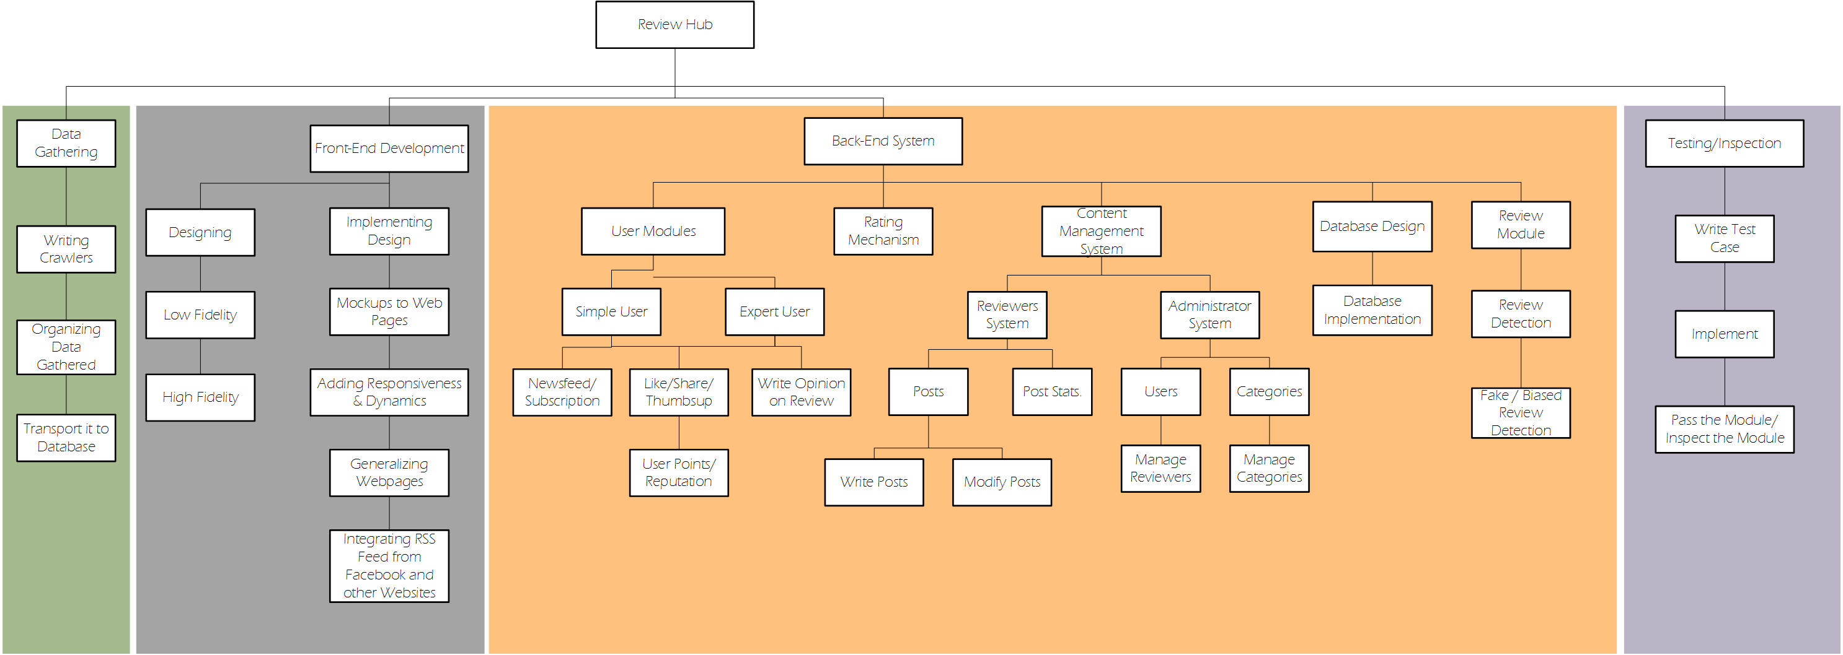

Figure 4 ReviewHub WBS

## Activity diagram

The following diagrams represent the basic flow of multiple activities on the website.

### User Sign In + Sign Up

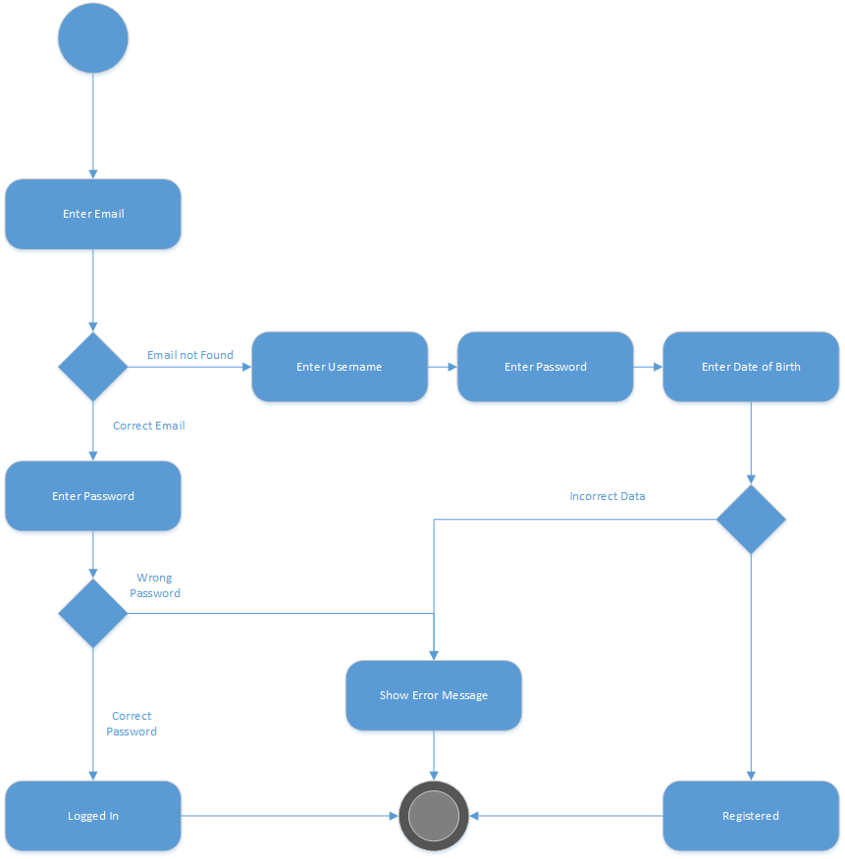

Figure 5 Sign in/Signup Activity

### Newsfeed

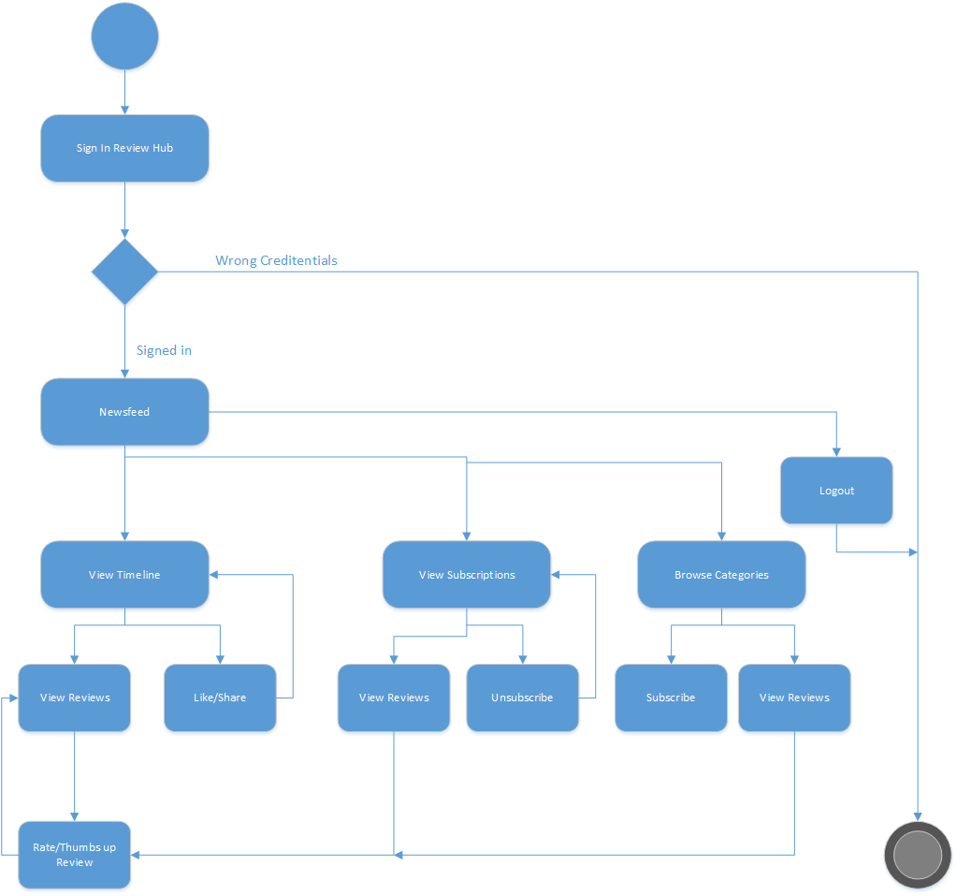

Figure 6 Newsfeed Activity

### Create Review

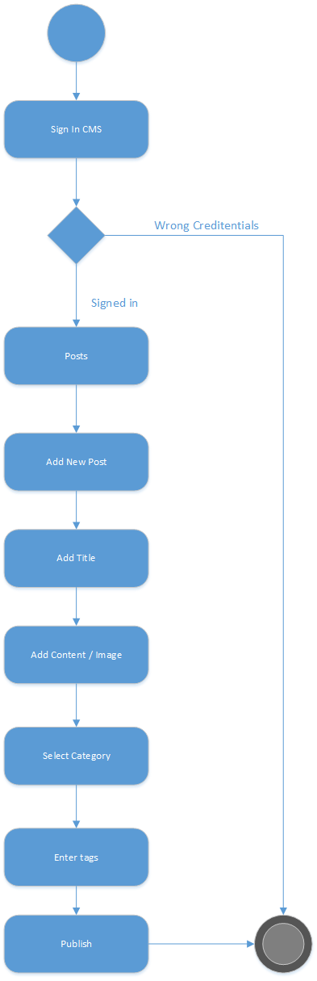

Figure 7 Create Review Activity

### CMS Login

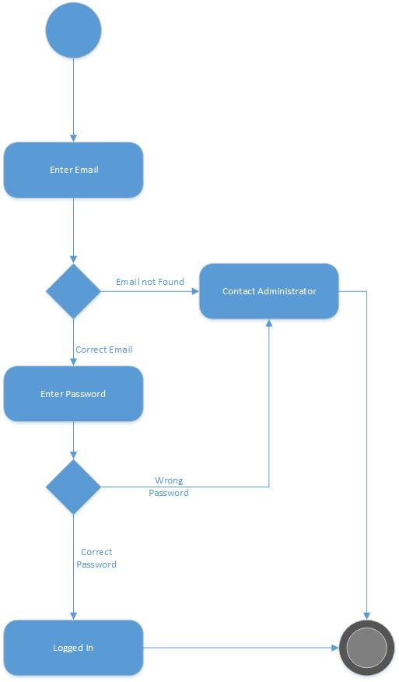

Figure 8 CMS Login Activity

## Database Design

A model of the database for the website.

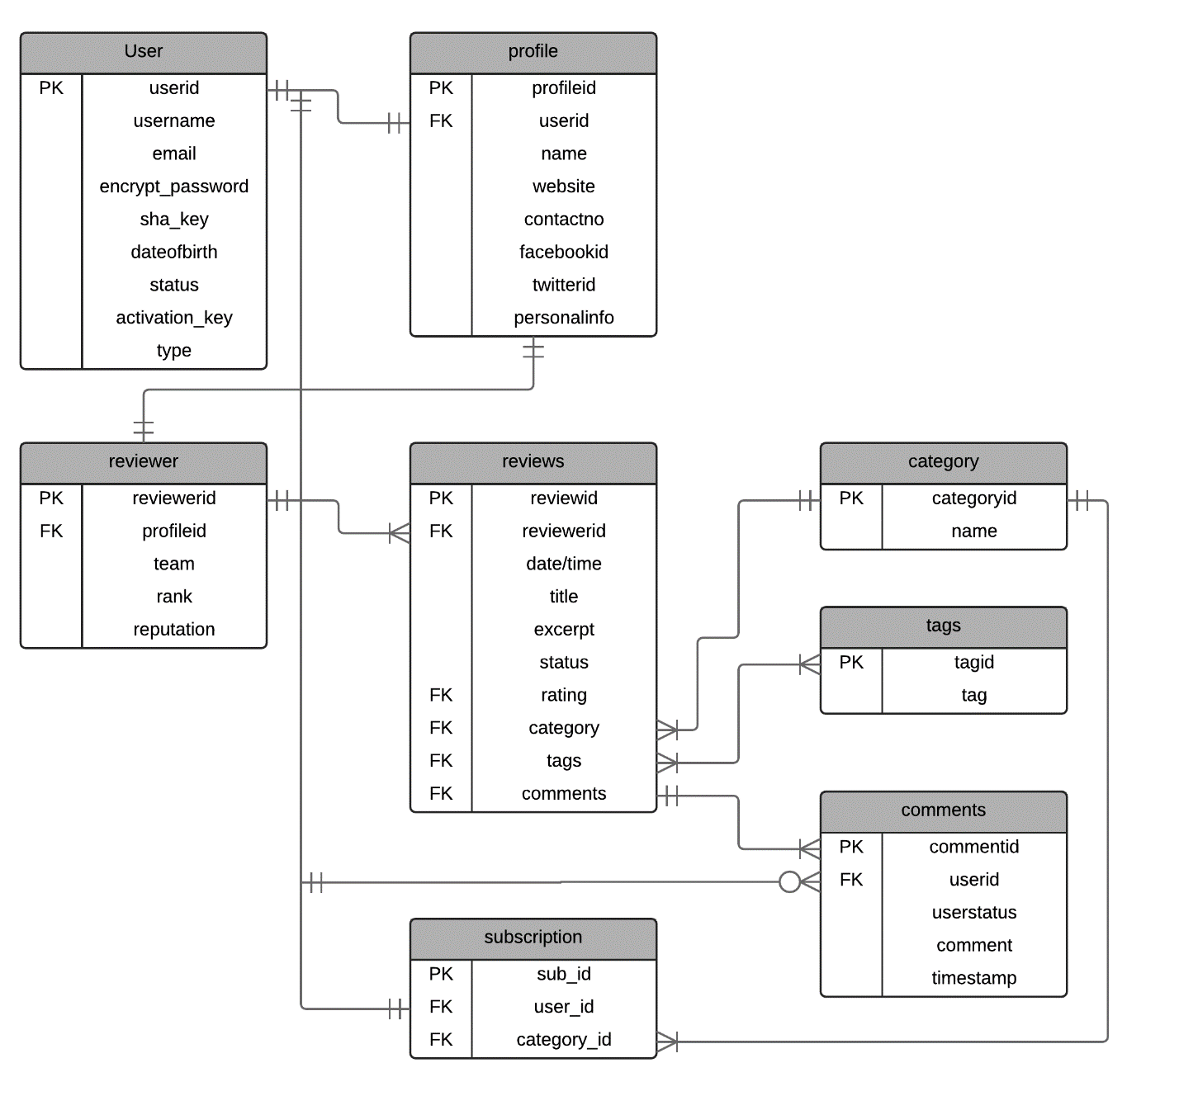

Figure 9 ReviewHub Database

## Gantt chart

Chart given below will be followed for tentative resources and scheduling.

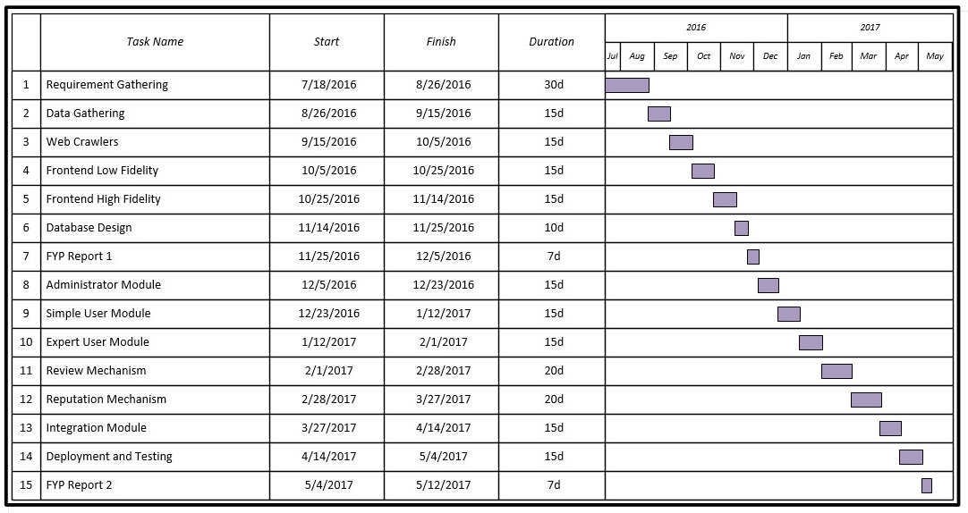

Figure 10 Gantt chart (ReviewHub)

# Risk Analysis

This section defines and analyzes the likelihood of damage or loss that maybe caused by external or internal vulnerabilities.

## Risks

The following defines a set of possible risks.

**Legends**

|  |  |
| --- | --- |
| Category | Impact |
| PS = Project Size Risk | 1= Catastrophic |
| BU = Business Risk, | 2= Critical |
| CU=Customer, | 3= Marginal |
| TE= Technology, | 4= Negligible |
| DE= Development Environment |  |

|  |  |  |  |  |
| --- | --- | --- | --- | --- |
| **Risk** | **Category** | **Probability** | **Impact** | **RMMM** |
| Large Number Of User Than Planned | PS | 40% | 3 | 1 |
| Less Reuse Than Planned | PS | 80% | 2 | 2 |
| End-Users Resist System | BU | 20% | 3 | 3 |
| Technology Will Not Meet Expectations | TE | 70% | 1 | 4 |
| Staff Inexperienced | DE | 40% | 2 | 5 |
| Web Site Attacks (DDOS , XSS, Malware) | TE | 50% | 2 | 6 |
| Load On Server/Too Much Traffic | TE | 60% | 2 | 7 |
| Database Loss/Leak | DE | 30% | 1 | 8 |
| System Infiltration | TE | 20% | 1 | 9 |
| Market Outdates (Category Wise) | BU | 50% | 3 | 10 |
| Non-Collaboration With Other Relative Business (Revenue Generation) | BU | 60% | 3 | 11 |
| Compatibility Issue Across Present/Future Platform (Browsers) | DE | 40% | 2 | 12 |
| Fake Review Detection Technology Failure | DE | 80% | 2 | 13 |

## RMMM (Risk Mitigation, Monitoring, and Management)

The following defines strategies for dealing with preceding risks

1. Monitor the number of users using the service and expand the system according to it.
2. Research beforehand how much resource is reusable .If the planned resource is not usable up to the mark then increase the workforce to cover the gap.
3. Make user friendly design and change accordingly to the user feedback/suggestion. We will try to improve the design/functionality of the application by keeping the feedback of user in front of us.
4. Research beforehand how much technology is capable .If the planned technology is not usable up to the mark then switch to other alternative but be sure to check the documentation of the technology beforehand.
5. Training session should be given to staff before bringing them development of application.
6. Technology should be secure and your defensive system should be running 24/7. Also keep backup servers for immediate shifting in case of DDOS attack and backup your site often.
7. Traffic should be well monitored, well managed and well distributed across multiple servers. We should create mirror servers to assist traffic.
8. We should use highly secure and repute database technology. Defensive system should be running 24/7 and take regular backup of database.
9. Regular monitoring and check-up of system from time to time in order to eliminate malicious code or backdoor.
10. Observe market trends and target popular present trends and mostly future trends. Learn to adapt and drop outdated market.
11. Increase link market circle and collaborate with multiple businesses. Try to gain as much sponsors as you can and take up ads for revenue generation.
12. Choose such type of technology which scalable to multiple platforms and constantly monitor the change in technology market/trend and evolve accordingly to it.
13. Implement certified and authenticated review detection algorithms and have external support to verify the technology and find any loopholes if present.

# Conclusion

This section will holds project summary and future work of the project

## Project Summary

“ReviewHub” if achieve its all goals and objectives mentioned above then it will be need of people in no time. It is the fact that many review sites are already available but a full fledge package will available for the people of Pakistan where they can see reviews given by authentic reviewers and eradicate or minimizes the risk while buying the product or service with having knowledge about it or by knowing the performance as well. As we are targeting major and different categories of great interest like cell phone, technology gadgets, movies and food. Our website also tell whether the review is fake or genuine which will also gain people trust and they will rely before getting any product or service. . If the “ReviewHub” launches by executing all its features then it will include a sense of luxury, comfort and a piece of mind for the people of Pakistan.

## Future Work

* Initiating our application with reviewing the things of different categories, future would possibly introduce other categories too, like wearable (clothing, shoes, jewellery, and watches) would be added in future. Future work would also improve the initial version of application by adding multinational brands.
* Future versions would introduce payment method of visa card i.e. online payment method.
* The future work of this project includes the extension of different categories and the availability of this application on iOS, Android, Windows Phone platform.

# References

1. *Opinion mining and sentiment analysis.* **Pang, Bo and Lee, Lillian.** 2008, Foundations and Trends in Information Retrieval.

2. *Consumer Awareness and Use of Product Review Websites.* **Bailey, Ainsworth Anthony.** 1, 2013, Vol. 6.